To recite the number names in order to 50 and beyond.
By the end of this half term, children should be able to count to 50 confidently, easily and quickly.
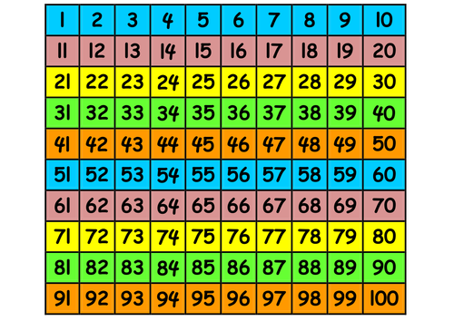
Perhaps start off using part of a 100 square (see below) and as confidence grows try without any aides. Also try starting at different numbers and asking your child to continue counting on from e.g. 15.

Once they are confident to 50 try beyond 50.

Top Tips
The secret to success is practising little and often. Use time wisely. Can you practise these KIRFs while walking to school or during a car journey?
Make it fun by using interactive resources such as Splat 100 square:
https://www.primarygames.co.uk/pg2/splat/splatsq100.html

To know all number bonds to 5.

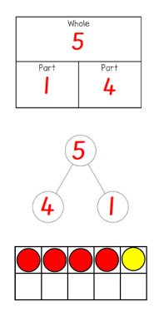
By the end of this half term, children should know the following facts. The aim is for them to recall these facts instantly.
Key vocabulary
add
plus
equals
altogether
part
whole
0 + 1= 1  1 + 0 = 1  0 + 2 = 2  1 + 1 = 2  2 + 0 = 2  0 + 3 = 3  1 + 2 = 3  2 + 1 = 3  3 + 0 = 3 | 0 + 4 = 4  1+ 3 = 4  2 + 2 = 4  3 + 1 = 4  4 + 0 = 4 | 0 + 5 = 5  1 + 4 = 5  2 + 3 = 5  3 + 2 = 5  4 + 1 = 5  5 + 0 = 5

The aim is for them to know the pairs of numbers that make the numbers 1 to 5.

Top Tips
You don’t need to practise them all at once. Maybe focus on 1 number a day. How many ways can you make this number?
Use practical resources – Your child has one potato on their plate and you give them three more. Can they predict how many they will have now?
Make a poster – We use Numicon at school. You can find pictures of the Numicon shapes here:http://fdslive.oup.com/www.oup.com/oxed/primary/maths/numicon/Numicon_pcms_Shapes,_Numerals_and_Number_Words_1-10_(Actual_Size).pdf?region=uk- your child could make a poster showing the different ways of making 5.
Play games – You can play number bond pairs online at: http://www.conkermaths.org/cmweb.nsf/pages/numberbondpairs.html
https://www.topmarks.co.uk/learning-to-count/ladybird-spots - put dots on the ladybird
https://www.nctm.org/Classroom-Resources/Illuminations/Interactives/Five-Frame/ - using a 5 frame

