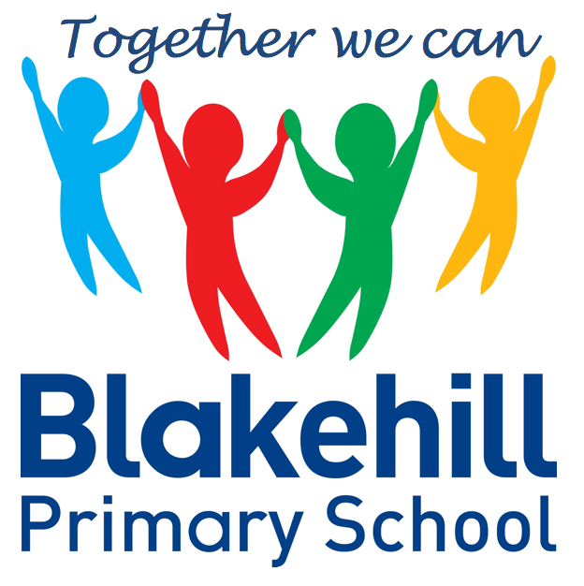
Personal, Social & Emotional
Children will be taking part in weekly circle times. They will have the opportunity to talk about themselves and their family. Children will be encouraged to take turns and listen to each other. We will also be talking about our wider school family. Children will also be learning more about how to look after their teeth.

Writing
During this half term we will begin focused phonics teaching every day. The first set of graphemes we will learn are, s,a,t,p,i,n, m and d. When the children know these sounds they will start to blend them to make words. Children will be practising name writing daily and learning the correct formation for each letter. We will begin to send home reading books linked to our phonics and also sets of high frequency words which we would like children to practise reading at home. Texts we are working on this half term include Stickman ….

We will start this half-term with work on Black History Month and also looking at Remembrance and Bonfire Safety. We will talk about our own lives and families, then look at similarities and differences among families, communities and traditions, for example Diwali. We will look at changes in seasons and features of our immediate environment and do a fieldwork study on our school environment. In the build up to Christmas we will be finding out about the Christmas Story and hopefully skyping a very busy man!

Understanding
the World
We begin every morning with ‘Go Noodle’ to get active and every afternoon with ‘Dough Disco’ to work on our fine motor skills. This will help to prepare us for writing and develop pencil grip and control. There will be many opportunities for children to play outside during this half term.. Every Friday children will do PE with Mr
Simmons, our PE coach.

Putting on our jumpers/coats independently

Children will move on from bringing home a story book to share with you to a phonics based book. Please ensure your child keeps their reading record in their book bag and practise reading any sets of words sent home as often as possible.
Children will have the chance to work creatively every day. There will be weekly music sessions with Mrs Carter. This half term children will be singing familiar songs and nursery rhymes. They will be exploring sounds and will have the opportunity to use different musical instruments.

Book Bags- Please remember that your child needs to bring their book bag to school every day.
Water bottles- Please make sure that your child has a clearly named water bottle in school every day. Please don’t transport your water bottle in your book bag as the water can damage the reading books if they leak. Please also make sure that the bottle contains only water and not juice.
PE kit- Your child doesn’t need an indoor PE kit in school at the present time. In line with our Covid procedures please could you send your child into school in their outdoor PE kit each Friday.

Other information
Half Term Curriculum Overview

We will be doing a maths session after lunch daily. Our topics for this half-term will be:

It’s Me 1 2 3! - Representing 1 2 3 / Comparing 1 2 3 / Composition of 1 2 3 / Circles and Triangles / Spatial Awareness

Light and Dark - Four / Five / One more and one less / Shapes with four sides /
Night and day

You can help at home by …

Mathematics
Physical Development
Reading
Expressive Art & Design

Reception Autumn 2 Term 2020
Magic and Celebrations!

