

What is the aim of the SEN and Pastoral Team?

To support children to develop their social, physical, emotional, language and communication needs.

To maintain an atmosphere in which children feel secure, are encouraged in their learning, growth and social development and know that they are valued within a healthy and safe environment.

Blakehill Primary School

Highfield Road, Idle, Bradford. BD10 8QN

Telephone: 01274 414355 Fax: 01274 414356

Email: office@blakehill.bradford.sch.uk

*Head of School: Mrs L Keighley*

SEN and Pastoral Care Newsletter 1 2020 Wednesday, 10th June 2020

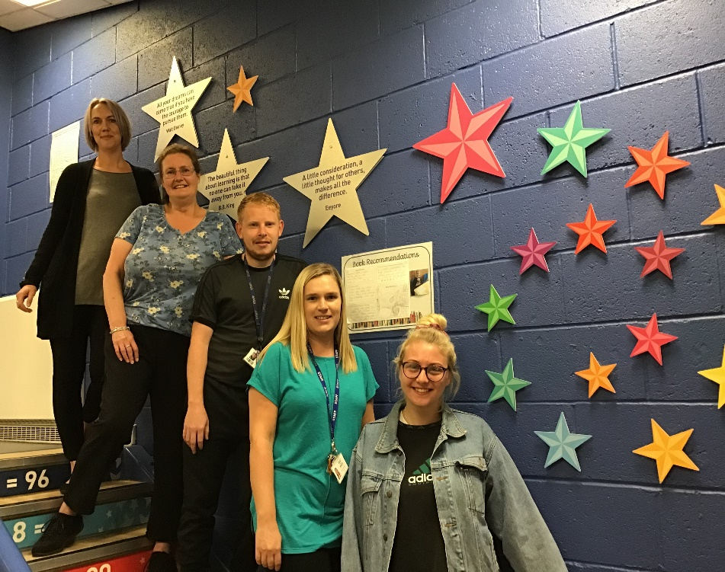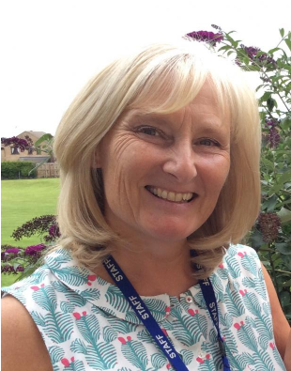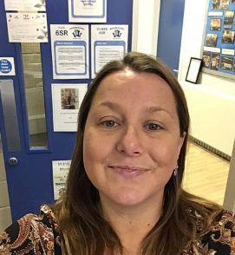

**Our SEN and Pastoral Team is here to:**

**Listen**

**Offer support**

**Promote positive behaviour**

**Identify the barriers to learning**

**Offer encouragement and build self-esteem and confidence.**

**Support parents through the MSP and EHCP process.**

Dear parents and friends,

We are hoping that this letter finds you all well. The return to school has been a trying time for most of us and we have had to become accustomed to new procedures in school, including the staggered start and end times to the school day. We appreciate your patience, support and for bearing with us while we continue to refine practices. The children have managed considerably well with the changes to their school day and staff are proud of their attitudes and behaviours.

As Blakehill Primary School’s Special Education Needs and Disability Coordinators (SENCO), we are here to offer support and advice regarding additional needs or SEND support for your child. It is important to us that you feel supported and that you are able to talk to us about your concerns or ask us any questions.

Whilst it is difficult to meet face to face at the moment, we are still available to speak to parents and answer any questions or respond to concerns.

Many thanks,

Mrs Gould and Mrs Pinder

and Pastoral care.

As Blakehill Primary School’s Special Education Needs and Disability Coordinators (SENDCo), we are here to offer support and advice regarding additional needs or SEND support for your child. At Blakehill, we are proud of our ‘open door’ policy so please do not hesitate to get in touch, if you have any concerns or need some support. We are available for meetings on Wednesday’s after school, you can sign up for an appointment in the office. Alternatively, you can make an alternative appointment by phoning the office.

Many thanks,

Mrs Gould and Mrs Pinder

As Blakehill Primary School’s Special Education Needs and Disability Coordinators (SENDCo), we are here to offer support and advice regarding additional needs or SEND support for your child. At Blakehill, we are proud of our ‘open door’ policy so please do not hesitate to get in touch, if you have any concerns or need some support. We are available for meetings on Wednesday’s after school, you can sign up for an appointment in the office. Alternatively, you can make an alternative appointment by phoning the office.

Many thanks,

Mrs Gould and Mrs Pinder

Meet the Special Needs Coordinators

Meet the Team

Mrs Ingham, Mrs Head, Sean (playworker) and Mrs Marsay offer SEN and pastoral support in our Hub.

The Hub offers a personalised curriculum in core learning for children with complex needs and supports social and communication skills and life skills.

Mrs Pinder is our fantastic SENCO who leads SEN in Key Stage One. She is teaching in Reception class

Mrs Gould is one of our Assistant Head teachers leading the SEN and Pastoral team. She also teaches in Year 5.



**My Support Plans (MSP) and Education Health and Care Plans (EHCPs)**

Some children with SEND may need extra support. If this is the case, then we will arrange a meeting with parents to discuss what is needed to put together a My Support Plan (MSP). A My Support Plan is used to record and review the provision in place to support children with SEND.

Some children with SEND may need support from professionals outside of the school setting to support them in achieving a successful learning journey. The recommendations from outside agencies will be considered when drawing up the My Support Plan. This could include:

* Parents/carers seeking medical advice about the young person.
* School requesting 0-25 Inclusive Education services involvement with the young person.
* School requesting advice from specialist disability teams.

EDUCATION HEALTH CARE PLAN (EHCP)

If a child has complex needs and requires significant additional support, school may request an education, health and care assessment with a view to securing an EHCP for the child.

Bradford Children’s Services SEN department will be responsible for the EHCP and reviews will be held at least once a year to ensure the pupil’s needs are being met. When considering whether a child requires an EHCP, school and the local authority will refer to the Bradford Matrix of needs. A copy of this can be found under the SEN section of the school website.



Mrs Bottomley is the Learning Mentor at our school.  Her role is to work with pupils, parents, staff and other outside agencies to identify strategies that help children to get more out of their time in school.

Mrs Bottomley’s aim is to help children practice skills that will help them to concentrate in the classroom and to build up positive relationships with both children and adults.  She will also help children to develop confidence and self esteem. Parents can, and are encouraged to, contact Mrs Bottomley to discuss the work their child will be doing or to check on their child's progress.

Mrs Bottomley will on the playground every morning or should you need to contact her, please call 01274 414355

Communication

It is important to us that we make sure we maintain strong communication links between home and school. Staff in The Hub are using the Marvellous Me app and telephone calls to engage with parents and children.

In the past, we have held parent workshop mornings where parents have visited The Hub. Due to Covid restrictions, we are not able to hold these meetings at the current time but we will continue to follow government guidance.

**Learning Mentor**

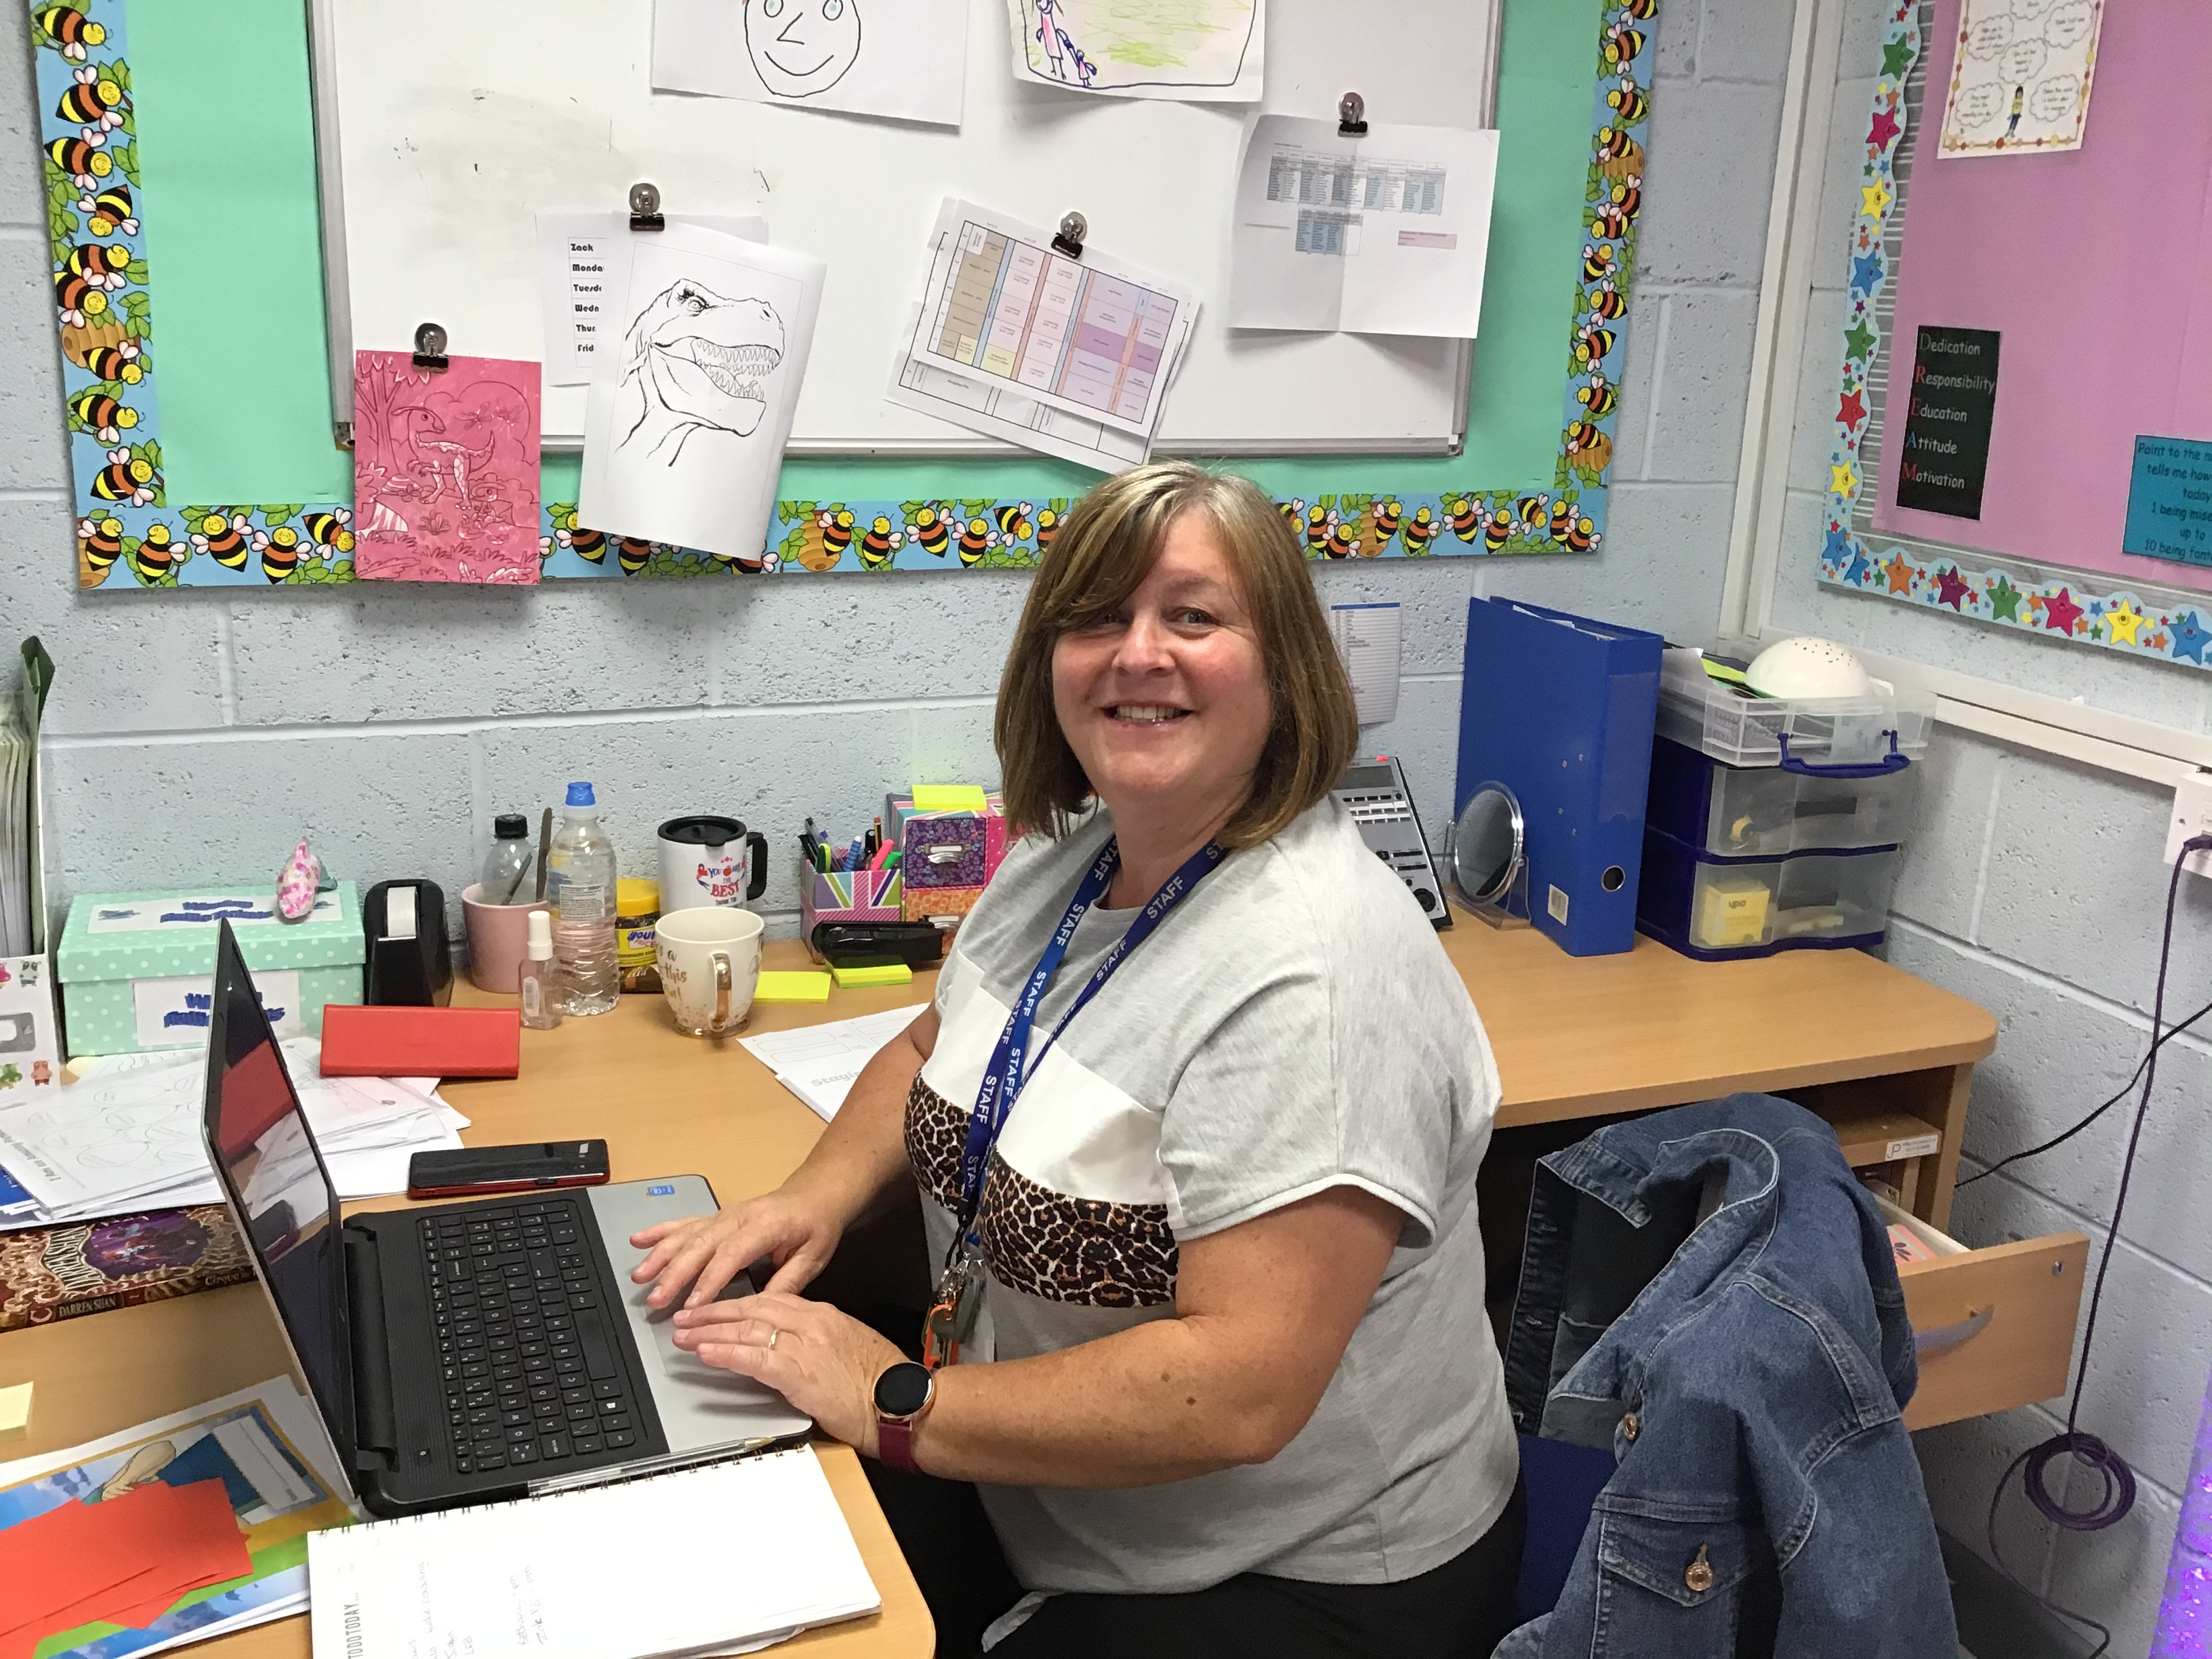

Our Hub

Our Hub is an additional provision for children with SEND. It offers core learning with a high adult to child ratio in the mornings and sessions to develop life skills, social skills and communication skills in the afternoons. Inside the hub is a calm learning environment where children receive a personalised curriculum with a ratio of 1 adult to 3 children.

Children may access the hub at different times of the week to support the provision of the quality first teaching that they receive in class.

What strategies do our SEN and Pastoral Leaders use to remove barriers to learning?

Personalised provision for children with complex needs.

One to one mentoring sessions to identify and discuss learning barriers.

Individual or group sessions focusing on a particular barrier such as: bullying, self-esteem or regulating emotions.

Group activities such as circle time and friendship groups.

Utilisation of child’s own hobbies or interests to remove barriers to learning.

Peer mentoring and buddying.

Liaise with parents and other agencies when in the best interest of the child/ family and school.

SEN and Pastoral Care Newsletter 1 2020



Parent Forum

We would like to develop the communication from parents and gain their views on SEND in school. We like to start a Parents’ Forum where parents can meet together with the SENCOs and ask questions and share their experiences. Under the current restrictions, we are unable to invite parents into school but we will be looking to start this when restrictions are lifted.

SEN and Pastoral Care Newsletter 1 2020

Speak to the SENCO or Class Teacher

We do not want the current Covid19 restrictions to stop parents from speaking to the school about their child. Meetings can still be held to discuss provision and progress. These meetings can take place via phone call or a Zoom meeting. Should wish to arrange a meeting, please email the school office.

SENDIASS

Bradford SENDIASS is for parents and carers of children and young people 0-25 with special educational needs and disabilities (SEND) in the Bradford area.  
The staff help parents and children to work together with schools and the local authority so that they have a good understanding of what support is needed and to make sure that it is put in place. The Special Educational Needs and Disabilities Information Advice and Support Services (SENDIASS) offer information, advice and support for parents and will support parents and school with MSP and EHCP process.

The service is free, impartial and confidential.

The number for the Bradford Office is   
01274 513300

**Blakehill SEN Parent Support Group**

**The Blakehill SEN Parent Support Group is a Facebook group run by Blakehill parents. The group is a closed, private group which offers parents the chance to talk about their experiences, share concerns and advice and signpost each other to further support groups. The group is a positive and friendly group where parents help and support each other. If you would like to be a part of the group, please find it on the Facebook.**

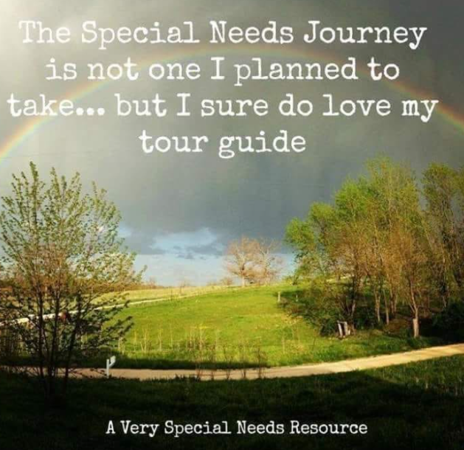

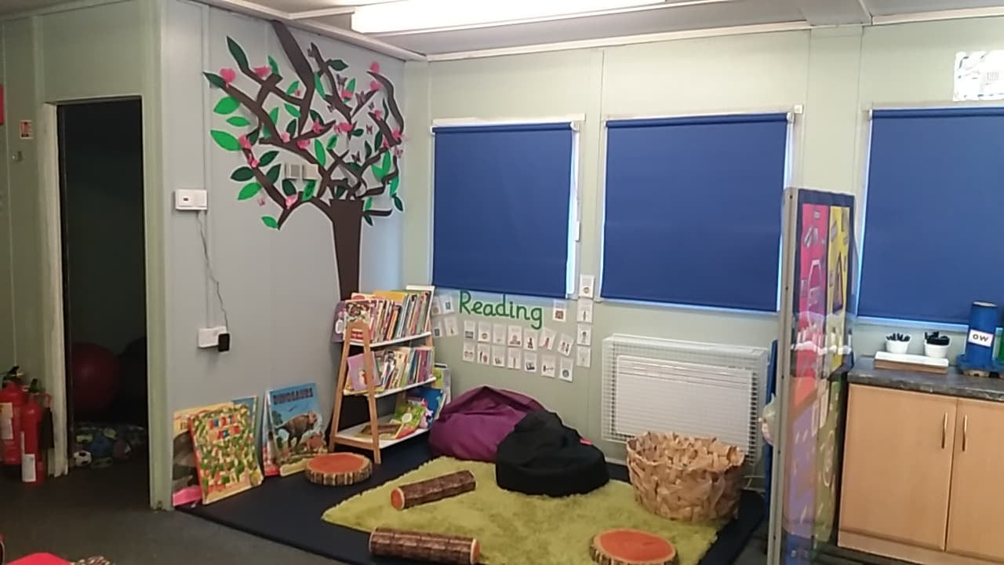

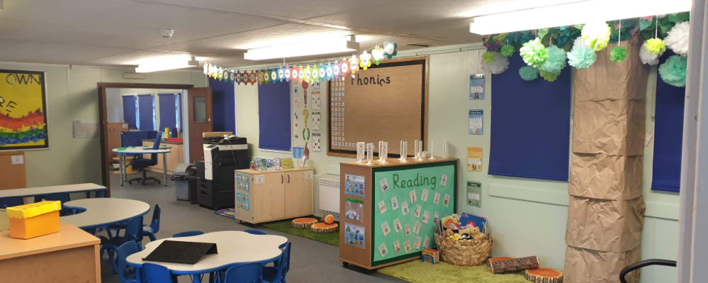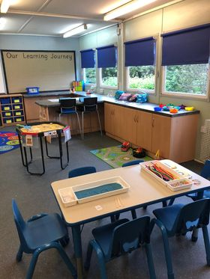

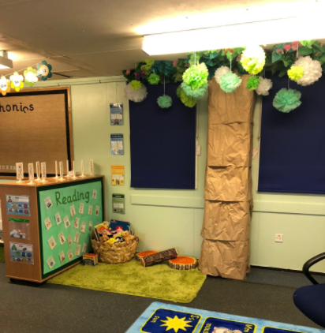

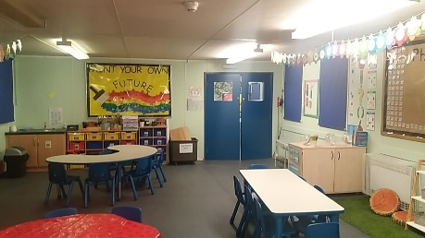

We are incredibly proud of our new look Hub which we now share with the Night Owls and Early Birds