+ - x ÷

Blakehill Primary School
Mathematics Procedures and Guidance Overview

‘Together we can’

Purpose
- At Blakehill Primary School we are on a journey to change the way mathematics is taught in order to improve attainment and raise achievement for our pupils. If you are taking a look around the school - walking through the corridors, observing lessons or scrutinising pupils’ books – or are a staff member seeking guidance, this document will outline some of the things you will see, things that may look different to other schools, or the way things looked a few years ago, along with key procedures we follow.
Philosophy
- Our mathematics philosophy is:

Mathematics: Everyone can!

We believe that through a combination of:
- outstanding teaching
- a mastery curriculum that devotes time to a particular area of mathematics, provides consistent models and images and has challenging resources and activities
- well-targeted, same-day / next-day or bespoke interventions
- and a culture of perseverance and determination
everyone can achieve and succeed in mathematics at Blakehill Primary School.
Aims
- We aim to ensure that all children receive a mathematical education that provides them with a firm foundation from which to understand the world, reason mathematically, appreciate the beauty and power of mathematics and develop a sense of enjoyment and curiosity about the subject and its links to other areas of the curriculum, including pupils spiritual, moral, social and cultural development.

- We aim for all our children to be confident, secure mathematicians because they are:
- fluent in the fundamentals of mathematic so that children can recall and apply their knowledge rapidly and accurately.
- able to reason mathematically by following a line of enquiry, conjecturing relationships and generalisations, and developing an argument, justification or proof using mathematical language.
- able to solve problems by applying their mathematics to a variety of routine and non-routine problems with increasing sophistication, including breaking down problems into a series of simpler steps and persevering in seeking solutions.
Mathematics Planning
- The teaching of mathematics follows our mastery curriculum which is based upon the White Rose Maths Hub scheme of learning. Long term (Year 1-6 overviews) and medium term plans (Years 1-6 Autumn, Spring and Summer Schemes), taken from the White Rose Maths Hub, are clearly set out for each year group in order to ensure coverage and progression through the programmes of study. These have been adjusted to allow longer study on particular topics. Short term planning guidance (Textbook Mapping and Lesson Breakdown / Maths No Problem) can be found from the White Rose Maths Hub, along with suggestions for appropriate resources and lesson objectives.
- Teachers can use a planning template which suits their individual needs, including the use of SMART Notebook rather than Microsoft Word. Teachers are expected to plan for deep coverage of the curriculum, making clear the lesson objective, teacher input and pupil activities. Fluency, reasoning and problem solving activities will form the basis of all lessons, where appropriate, with all children working through these types of questions. Teachers will also consider what scaffolding may be required for children who may struggle to grasp concepts in the lesson and suitable challenge activities for the more and most-able.
Planning example:
Long term plan – White Rose Maths Hub Mastery Overview Term by Term (available for Year 1 – 6):
E.g.
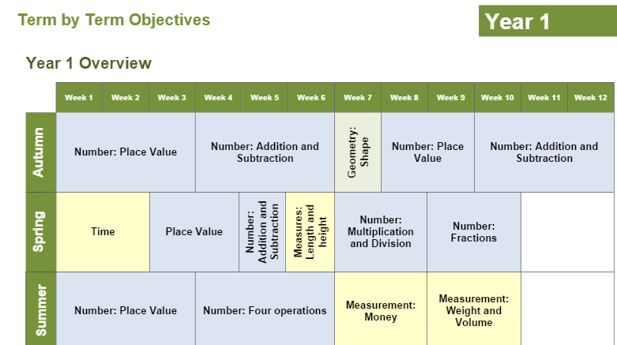
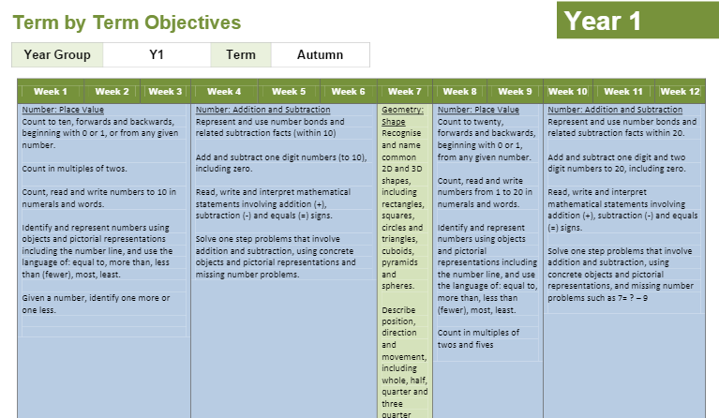
Medium term plan – White Rose Maths Hub Mastery Overview (available for Autumn, Spring and Summer for Year 1 – 6)
E.g.

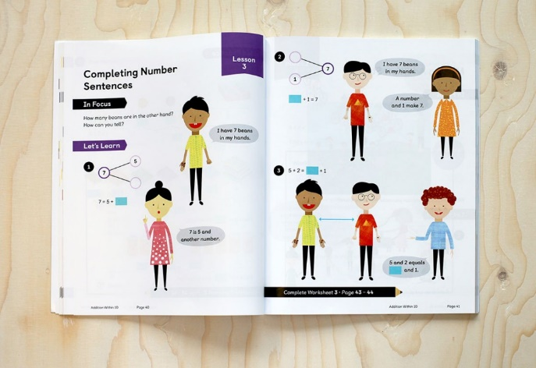
Short term plan – White Rose Maths Hub / Surrey Maths Hub Lesson Breakdown and Textbook Mapping (available for Autumn, Spring and Summer for Year 1 – 6). You may find it useful to use the lesson ideas from the Maths No Problem or Power Maths textbooks.
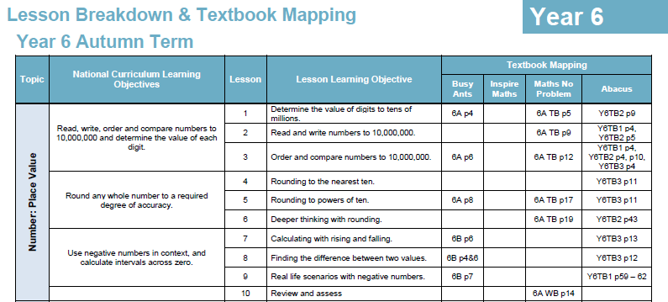

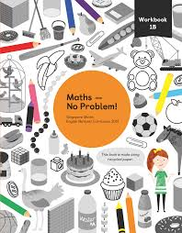
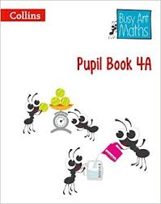
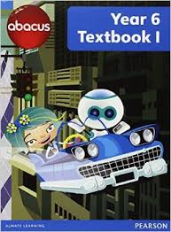
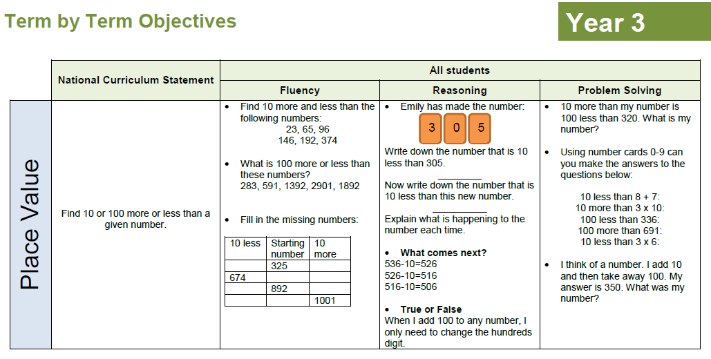
Resources – White Rose Maths Hub activities, Busy Ant Maths, Abacus, Maths No Problem & Power Maths textbooks. Activities can be found on the White Rose Maths Hub / Surrey Maths Hub Lesson Breakdown and Textbook Mapping, as above.

- Classes are taught in a range of groupings. Teachers will use a range of grouping methods when planning. Ability groupings are dynamic with children moving between sets when necessary. However, we are in the process of phasing out sets as the theory of mixed ability sets favours recent research and the White Rose Maths Hub. No children miss out on the daily mathematics lesson. Teachers are also encouraged to be flexible and adapt their plans depending on the needs of individuals, groups or the class, or by the topic which the class is studying.
- Work should be appropriately differentiated to meet the needs of all learners. Differentiation may be through the use of an adult, the use of equipment, encouraging children to explain and reason, or through the use of more rich and sophisticated problems for those who have grasped content quickly and need to be moved on. It should not involve simply bigger numbers or moving on to additional content not covered by that year group.
- Mental and written calculations will also be taught in accordance with the National Curriculum. The use of practical resources, models and images will ensure that all children have a secure understanding of the methods being introduced. For more information please consult the School Written / Mental Calculations Procedures and Guidance.
- The total teaching time dedicated to Mathematics in ‘core’ lessons is five hours per week across Key Stage 1 (KS1) and Key Stage 2 (KS2). As well as this Teachers are expected to deliver a 15minute daily arithmetic session. This may vary in Reception. In addition to this, there may be explicit KIRF, Big Maths and RM Easimaths sessions, as well as cross-curricular links in other subjects.
Lesson structure
- Lessons focus on key conceptual ideas and connections are made across mathematical topics. To those observing it may appear that the pace of the lesson is slower, but pupil understanding and overall rates of progress is enhanced. Lessons are planned based on formative assessment of what pupils already know and we include all children in learning mathematical concepts.
- Instead of ‘Let me teach you…’ as a starting point, children are encouraged to explore a problem for themselves to see what they already know. The journey through the lesson consists of many small steps, however there will be several points when a ‘jump’ appears to have been made, or an extra challenge – this is what is expected.
- Teachers will use questioning throughout every lesson to check understanding and challenge those children who have grasped the concept. A variety of questions are used but you are most likely to hear the same ones being repeated e.g. How do you know? Can you prove it? Are you sure? Is that right? What is the same? What is different? Can you explain that? What does your partner think? Can you show me?
- Children are expected to listen to each other’s responses and may be asked to explain someone else’s ideas in their own words, or if they agree/disagree etc.
- Rapid intervention or same day / next day intervention is used throughout school. In mathematics new learning is built upon previous understanding, so in order for learning to progress and to keep the class together pupils need to be supported to keep up and areas of difficulty must be dealt with as and when they occur. We do this through rapid intervention. In addition, we still run intervention sessions outside of the maths lesson for some targeted children.
More / Most-able
- We make provision for the more and most-able in our mathematics lessons. These children will be challenged throughout in order to ensure that they achieve their potential.
- Provision for the more / most-able can be achieved in a variety of different ways including: detailed questioning; encouraging children to explain and reason what they have done; supporting other children who may struggle to grasp the required content; using sophisticated, challenging activities such as nRich, Badger Maths, Maths for the More Able, White Rose Maths Hub and Maths No Problem; and using Testbase. These challenges will be made explicit in pupil books.
- More / most-able children may also benefit from a bespoke or targeted intervention.

KIRFs
- We recognise the importance of establishing a secure foundation in mental calculation and the recall of number facts before standard written methods are introduced. This will be achieved through the frequent individual testing of the KIRFs.
- KIRFs are split into 6 stages to cover each year group. It is expected that most children will take 1 academic year to achieve their relevant year group’s KIRF stage. If a child has mastered their KIRF stage they may move on to the next KIRF stage. This is at the discretion of the class teacher.
- A record of what KIRF objective each child has achieved and which they are working on should be kept by the class teacher. This may be through a class list or through the KIRF booklet maintained by their maths teacher (if classes are set).
- KIRFs should be used to inform children of their next steps and targets in learning. Children will be made aware of their targets through frequent testing
Pupil books
- Every lesson should also have a date and learning objective (LO). The inclusion of a success criteria is at the discretion of the class teacher. A copy of the LO template can be found on: Teachers > Mathematics The marking of pupils’ books in mathematics follows that of the school marking policy. However, additional symbols are used to indicate adult support, use of concrete resources and so on. A copy of the additional marking symbols can be found on: Teachers > Mathematics. Children are encouraged to peer and self asses.
E.g.
25.04.17
LO: To understand the compact method for addition
A/GW AS I C CQ S/NDI

S/NDI | Same day/Next day intervention
A/GW | Adult led/Group work
AS | Adult support
C | Concrete resources
I | Independent
CQ | Challenge question

- Children’s maths books will be presented to the highest standard at all times, ensuring sheets are trimmed and stuck in neatly where appropriate.

Display boards / maths areas
- It is expected that classrooms will have a maths working wall in addition to maths display boards for each year group around school in order to raise the profile of the subject.
- Classrooms should have resources available that are easily accessible by pupils. Essential mathematics resources include: text books, counters, Numicon, multi-link, counting beads, number squares and so on.
- Electronic resources such as Big Maths, White Rose Maths Hub, Abacus and Badger Maths are available on the Teacher Drive.
The role of teaching assistants
- Teaching assistants are actively involved in teaching individual children, small groups and in providing intervention sessions. They support all groups in the classroom, enabling the teacher to also work with all groups. They demonstrate initiative in using practical resources to support learning and help pupils overcome difficulties. They are careful not to over-direct pupils’ learning. They spot misconceptions and gaps in learning, and take responsibility for assessing pupils in their groups, and help to identify the next steps and plan subsequent activities with the class teachers.
- Teachers must ensure the role of teaching assistants is clear to them before the start of a session.
Assessments
- Formative assessment of pupils’ attainment is continuous and ongoing and evidence is collected by observing pupils at work, questioning, talking and listening to them, considering the work they produce and discussing this with them. This level of assessment is designed to inform the planning of learning and the regular setting of targets for each pupil.
- All assessment is used to inform teaching and learning. We identify children’s understanding and then swiftly focus interventions to overcome misconceptions. Assessments will involve:
- Assessment for learning through daily mathematic lessons and other opportunities for mathematics.
- Half termly NFER (data submitted to senior leaders) and arithmetic assessments (data submitted to subject leaders).
- End of Key Stage national assessments.
Inclusion
- All children should have the opportunity to develop their mathematical potential to the highest standard possible, irrespective of gender, age, ethnic background or disability. We aim to encourage a positive attitude to learning and using mathematics in all our pupils. The ethos throughout school will ensure that contributions from all pupils will be respected and valued.
- Our aim is that all children are able to access and make progress through the mathematics curriculum. For every child to be able to participate we must know each of them as individuals. For children with SEND teaching must, where appropriate, be closely linked to their IEP or EHSCP targets. For further information please contact Maths Subject Leaders / SENCo.

Maths Subject Leaders
- Our Maths Subject Leaders must always be outstanding practitioners, leading by example. To tackle barriers and ensure consistency, they are responsible for:
- Monitoring teaching and learning through yearly scrutiny weeks (lesson observations, work scrutinies and pupil progress reviews.
- Using information gathered from data analysis to improve teaching and the curriculum.

- Offering support and guidance to teachers / teaching assistants, including sharing best practice throughout the school.
- Preparing and organising staff meeting and INSET training where necessary.
- The Maths Subject Leader will also work with other members of the Senior Leadership / Management Team and governors in raising standards in mathematics and maintaining the high profile of mathematics in the School Improvement Plan.

