Learning Goal: I can retrieve and infer information from the text.  wriggle, disliked, plain, ugly  explore, investigate, peaceful | 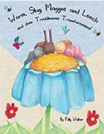
Home School Learning Lesson 2 - Worm, Slug, Maggot and Leech by Polly Walker
- Where did the animals live?
- What didn’t the animals like about themselves? How do you know?
- Draw an ugly animal and label it.

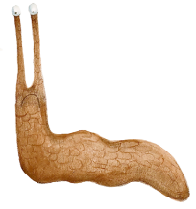
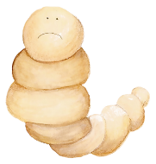
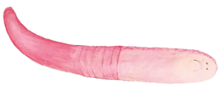
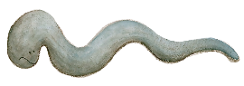

My Ugly Animal

