Who does it remind you of? | 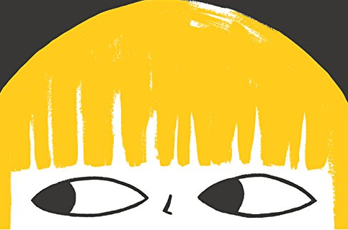  What do you think the character is looking at?
How does the image make you feel? | Who could the person be and why?
What does the image remind you of?

