Hello!
I am so happy to let you know that I will be your first class teacher at Blakehill Primary School when you begin in September. It will be a very exciting time for you and me as I am also going to be starting new in Reception class with you! We will have a lot to get used to together and will hopefully be able to help each other along!
Firstly, I thought I should tell you a little bit about myself. I have been at Blakehill for eight years. I began in Reception and then for the last four years I have been in year one. I am really excited to be getting back into Reception so that I can get to know you and work with you to help you in your learning. When I am not being a teacher at Blakehill I am a mum to two boys called Jack and Sam. They are older than you and have been really busy recently trying to keep up with their school work whilst they have had to stay at home. At the moment when I am at home I love to go out with my family for a walk and hopefully an ice cream! I also love to read, swim, bake and spend time with my friends and family.
It is a very strange time for us all at the moment and I would like nothing better than to invite you into school so you can meet me and see the classroom where we will be spending so much time together. Sadly, at the moment that is not able to happen so I am writing this to let you know a little bit more about what life at Blakehill will be like once you start.
Firstly, once you are in Blakehill you will be part of the best class in school! We will be known as RW (R stands for Reception and the W is for Wardell.) I will meet you every morning in the playground and we will go into school together to start our day. The most important thing to happen when you start school is for us all to have fun! I want you to love coming to school so we will have lots of interesting and exciting things planned to help you feel happy and safe at school. You will make lots of friends and learn so much whilst having the best time!
There are a few things that you can be doing at home over summer to help you get ready for school. These are:
- Practise getting dressed and undressed, making sure you can do the fastenings on your clothes. If you can do this, it will help you in your PE lessons.
- Practise putting your shoes on. Again this will help you when we are having our PE lessons or when we are putting our wellie boots on for going outside.
- Practise writing your name. There will be lots of children in the Reception unit (60) and if you all draw a picture we will need to know whose picture it is so that you can take it home to your family.
- Practise fastening your coat. Zips can be tricky! It can get very cold when we are outside so wearing your coat correctly is important.
- Making sure you can go to the toilet as independently as possible. It really will help you at school if you are going to the toilet, cleaning yourself with the toilet paper, flushing and not forgetting to wash your hands as independently as you can.
As well as myself in RW you will also have a lady called Mrs Donohue to help you. She is very excited and looks forward to meeting you! In the Reception unit there will also be the other class called RP, the adults working in RP are Mrs Pinder and Mrs Brook. They are really looking forward to meeting you too!
I will be in touch again soon to give you a little bit more information about life in reception. Mrs Pinder and I have lots planned for our year together with you and are eager to get started!
We hope you are just as excited as we are!
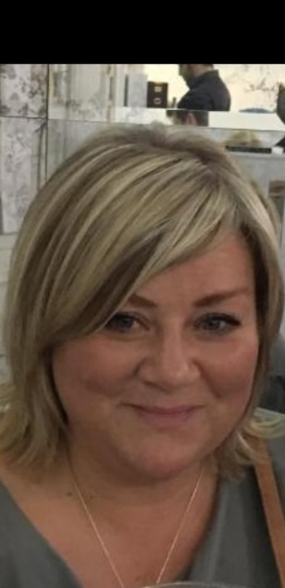
We can’t wait to meet you in September. Until then please stay safe and keep healthy.
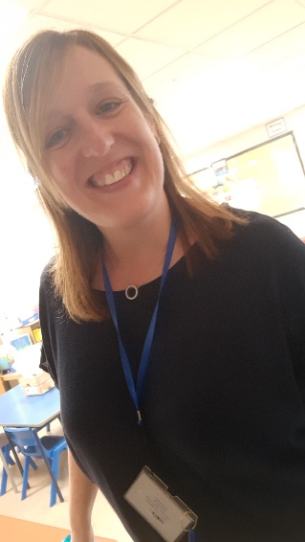

Mrs Wardell and Mrs Donohue
(Teacher) (Teaching Assistant)

