To say 1 more than a given number up to 10.
By the end of this half term, children should be able to say one more than any number up to 10.
1 more than…  1 is 2  2 is 3  3 is 4  4 is 5  5 is 6  6 is 7  7 is 8  8 is 9  9 is 10 | They might be able to record it as a calculation:  0 + 1 = 1  1 + 1 = 2  2 + 1 = 3  3 + 1 = 4  4 + 1= 5  5 + 1 = 6  6 + 1 = 7  7 + 1 = 8  8 + 1 = 9  9 + 1 = 10
Use a number line to hop along one more:
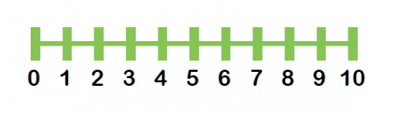
The aim is for them to say the number that is one more than the number you say to them. They may be able to say what one less would be too.

Top Tips
The secret to success is practising little and often. Use time wisely. Can you practise these KIRFs while walking to school or during a car journey?
Perhaps you could have number cards that you can show your child and they say which number is one more than that number.
https://www.topmarks.co.uk/learning-to-count/chopper-squad - one more than game
https://www.youtube.com/watch?v=Du6JHupzwVo&t=9s - one more song

