**Design Technology Vocabulary**

**Year 1**

**Mechanisms**

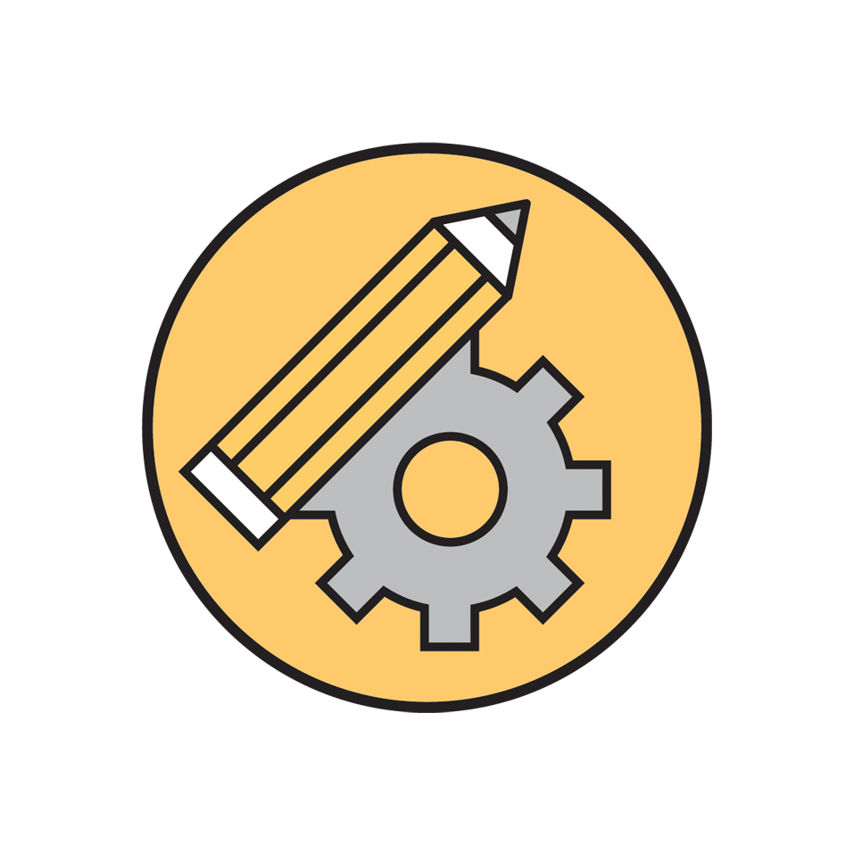

**Designing:**   
idea_______________________________  
discuss_____________________________  
choose______________________________  
drawing_____________________________  
labelling_____________________________

**Making:**   
hole punch___________________________  
paper fastener________________________  
join________________________________  
cut carefully_________________________  
planning_____________________________

**Knowledge and understanding:**  
moving _____________________________  
handle _____________________________  
lever ______________________________  
pivot ______________________________  
slider ______________________________  
direction ____________________________  
blade ______________________________  
metal ______________________________  
order ______________________________  
sequence ____________________________  
length ______________________________

**Types of movement:**  
balance ______________________________  
movement ____________________________  
forward ______________________________  
backwards ____________________________  
pull _________________________________  
push ________________________________

**Notes:**  
________________________________________________________________________________________________________________________________________________________________________________________________________________________________________________________________________________________________________________________________________________________________________________________________________________________________________________________________________________________________________________________________________________________________________________________________________________________________________________________________________