To know the multiplication and division facts for all times tables up to 12 x 12.
Year 5 children should already know ALL the times tables up to 12x12. The aim is for them to recall these facts instantly. This half term is a chance for Year 5 children to consolidate their knowledge of multiplication and division facts and to increase their speed of recall.
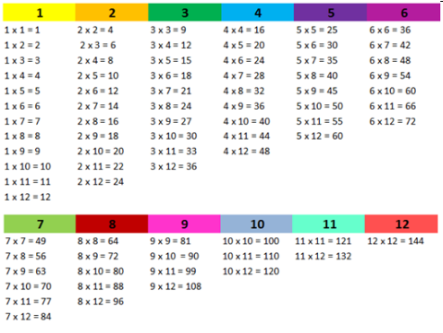 | Key Vocabulary  What is 12 multiplied by 6?  What is 7 times 8?  What is 84 divided by 7?
They should be able to answer these questions in any order, including missing number questions
e.g. 7 x ⃝ = 28 or ⃝ ÷ 6 = 7. Children who have already mastered their times tables should apply this knowledge to answer questions including decimals e.g. 0.7 × ⃝ = 4.2 or ⃝ ÷ 60 = 0.7

Top Tips
The secret to success is practising little and often. Use time wisely. Can you practise these KIRFs while walking to school or during a car journey? You don’t need to practise them all at once: perhaps you could start with one particular times tables and ensure they know all of them before moving onto another times table.
Speed Challenge – Take two packs of playing cards and remove the kings. Turn over two cards and ask your child to multiply the numbers together (Ace = 1, Jack = 11, Queen = 12). How many questions can they answer correctly in 2 minutes? Practise regularly and see if they can beat their high score.
https://www.topmarks.co.uk/maths-games/daily10 - Level 6 Multiplication/Level 5 Division https://play.ttrockstars.com/ - Children should be regularly practising their times tables on TTRS and improving their speed.

