Mother nature.
By Isabelle wilks.
My hair stood on end, a shiver raced down my spine and a lump came to my throat. It was him.......... I dont know who he is, all I know is that he means no good. My heart pumping fast, he slowly made his approach towards me. No. No No! He is so close, I can feel his breath on my forehead. I close my eyes.
"HELP" she yelled.
She opened her eyes. She was in her room, She knew it very well. In fact, she had been home all weekend. Her father was out to work, and her mother had passed away. She did not want to risk her life by going out.
I think now you want an introduction. Well here it is: This girls name is Fern coastal, And she had really light brown hair, Grey eyes and a very busy mind. She is quite a lighthearted girl, but can also be fairly mysterious.
Her father, Elphus coastal, is a very simple man. He is kind, careful and neat. He owns Black and grey hair that had once been brown. His eyes were green and large like a lizards.
And seana coastal, Ferns mother, was a kind and generous women, but died from....... well, no-one actually knows, it remains a mystery. Now the very strange thing about Fern is that she has a secret. She doesn't know about this secret and nor will you if you dont read the whole story.
Our story begins one normal Monday morning, when young fern had just woken up. She was in her 1st year of high school, however it was not as exciting as you would've thought. It was just..... well......... Merely satisfactory. She woke up to the sound of her ear-splitting alarm clock. Honestly, it sound like a bird trying to squawk at the same time as being strangled. Yeah. THAT bad.
"Seriously. I need to replace that aggravating alarm clock!" She thought to herself.
"IM HOME FERNY" Called a voice.
"Welcome back, dad!" Replied Fern.
Realising what time it was, Fern headed over in a rush to her wardrobe, pulled on her clothes and headed downstairs. Her father was standing in front of the old oven, with a smile on his face and a pan with 4 bits of bacon in it. "You can eat on the go."he said softly," oh and as well," He fixed her blue and silver tie that was a bit skew.
"Thanks father " she said in a tired voice.
She looked at her watch, her eyes widened, and she grabbed her sandwich and ran outside.
She saw her acquaintance, not friend nor foe, Elijah. He was a boy that owned black hair, blue eyes and a slight smile that always hung upon his face.
"G'morning fern." He yelled from his porch.
"Morning to you too," Fern replied. THUD. "What's that?" She thought. Oh. She forgot to zip up her bag. She picked up her book and pencil case and slotted them back into her galaxy bag and zipped it up. "Well, Your certainly a bit clumsy this morning." Came a voice.
"I sure am lottie." She replied. Lottie (Charlotte) Is ferns BFF and she super kind and honest. They have known each other since year 4 when Fern arrived at Bluescotts primary. "Would ya look at the time Fe!" Exclaimed lottie, "we gotta go!"
5 minutes later, they arrived at school and looked up and the building. "Beautiful isn't it?" Whispered fern.
"Sure is Fe" agreed lottie. "And..................... that's our cue! Got to go to math!"
Fern looked at her phone. She looked at it and read she had biology first.
When she arrived at biology, she saw miss jonsson handing out the start-of-term test results. She got an a+ which was good , and the rest of the lesson was alright. " Miss jonsson report to the head teacher's office." The speaker echoed.
"I guess I've got to go children. Be good." She explained before walking out the old beige door with a small thin window.
"What did all of you get on your test?" Asked Elijah,"I got a B+!" Rebbeca received an A- , Kayla got an F-. And you know what Fern got. When the teacher got back, they learnt Nutrition, digestion and excretion. Fern was quite confused at first, but eventually she understood.
rINGggggGGGG!!!!!! That was the bell for the end of class. A couple of "Phew"s came from the back of the class. Then she stood up and walked out of the classroom.
The lunch hall was crowded with people (as usual) and it took her a while to find a bench to sit on. She sat down and opened her bag. She had a small box of salt and pepper squid -calamari-, Some green olives and a water bottle. The reason she hadn't got much is because she was a VERY light eater. About 5 minutes later, her best friend,Charlotte ran through the door and came to sit with her. She was muttering something under breath, "Goodness. That evil witch. Such a monster!".
"Everything alright lottie?" Fern asked.
"No. Not at all." Charlotte replied in an angry way.
"What's up? You can tell me." Fern said slowly.
"Miss Smith is so mean! She kept me in for SNEEZING."
"CORONA VIRUS" Yelled fern.
Ok ok just joking. Fern did NOT yell Corona virus. Nor does it exist in that world so........ yeah. Just ignore that and pretend that it never happened. Back to the story.
They ate the rest of their lunch and then headed out for some fresh air.
A few boring hours later, It was time to go home. She got her Coat and her bag on put them on. She then walked out the doors and started the journey home. It was starting to shower a bit, so Fern pulled her hood up and zipped up her coat. The navy sky hung above the bustling city. Fern loved her life. Except what happened to her mother, Her life was perfect. But she knew this could not last forever. It was just, too good to be true. Life never comes easy. Just when life is at it's best, you turn a corner and nothing will ever be the same again.
...
...
...
BANG! she was right. Something was going to happen. But what? "Should I turn round? Is it safe? What was that? Or mabye it was just some ally cats?" She thought, "Or............! Could it be?? Really? No, it cant be. It's not that fern. It's not!" Fern took a deep breath and turned around...... she can see something. So Fern walked slowly into the alleyway only too see,
A person. Looking straight at her. Why? No one knows. "Who are you?" She managed to say. The person grinned.
"Hello. Fern coastal." The stranger muttered. Fern looked him in the eye.
"Go away now" she instructed him. To her surprise, his eye turned purple and he said,
"Of course" What. Just. Happened?! Did she just, Control him? Mabye it was the eye contact? Ok, that was crazy. Before anything else happened, Fern ran home in a rush. She ran through the streets, and back home.
"DAD" she yelled "something BIZARRE just happened" she was sat on the dinning room table.
"Fern" something called
"Who is that"
"Mother nature"
"Really?"
"Yes Fern. I am mother nature"
"how do you know my name?"
"I am Seana Costal. Your mother."
"M-mom?"
"That's me. I need to tell you something. You are part of nature."
"Really"
"Good afternoon fern. Her dad said whilst coming down the stairs. He was wearing his suit that he always wore to work.
"Good Afternoon dad!"she replied .
"Your in a good mood this afternoon" he said, " I think I know why. Is it because your mother Whispered to you?"
"How did you know?" She asked
He told her the whole story, " So, on my first day of high school, I met your mother. She was quite shy but was a pleasure to talk to. Right there and then, I knew we were ment for eachother. We would hang out every day, eat lunch together every day and it was amazing. But one day she came in and took me straight into the cleaners cupboard. She pulled her sleeve up only to show me a mark on her wrist.

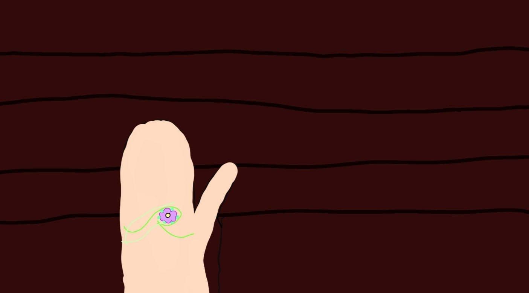
It was beautiful and I remembered it from a book, it meant that this person was the new mother nature. I told her i was so proud and happy for her. And that's all."
"Wow" Fern said in an amazed voice "Mum was so lucky!"
"Ahhhhh. She was not lucky Fern, she was fit for the place. She was kind, gentle and wise. It is all about the personality of the person." He told fern." And that, is why I think, that at the strike of midnight, when the church bells ring, within each chime the mark will appear on your wrist." He told her. Fern thought that wasn't going to happen so she just carried on like normal. 4: 47. She played Stardew Valley and met a few NPCs ( non player character) and brushed her hair. 5: 00. She nodded of. 5: 15. Her dad called her for dinner. They had burritos beacause it reminded them of there old house, which was in Mexico.
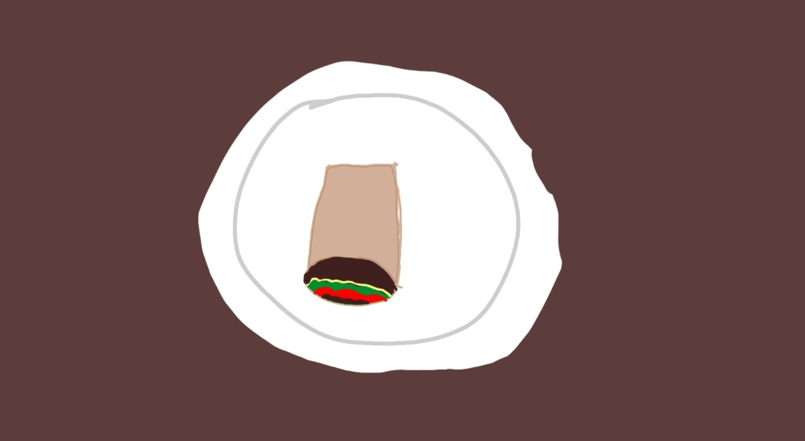
After that, she went upstairs to have an
E
a
r
l
y

Night.
Fern fell asleep really quickly, and eventually it was 11:59. The church stood there, right next to the house, ready to chime its bells.
12:00.
MIDNIGHT. The time when everything changes. A new day, a new surprise. DING. chime 1. What do I see appearing on Ferns wrist?
DING. Chime 2. Something is happening........... DING. Chime 3. DING. Chime 4. The mark......... DING. Chime 5. DING. CHIME 6. Her wrist. Its definitely starting to get the mark. DING. Chime 7. "Stupid bell. Waking me up" muttered Fern. "My wrist, MY WRIST! Oh my, dad was right! I am next. I have been chosen!" DING. Chime 8. DING. Chime 9. DING. Chime 10. DING. Chime 12. The mark had fully appeared an voices came from nowhere. And they said this;
" nature needs a new mother. She has been chosen. She is Fern coastal. She was named Fern because she had already been chosen.
Fern coastal,
Fern who lives by the coast.
In Marseille, France.
Is now mother nature,
Nature will always be there for her,
And she will always be there for
Nature.
You, Fern coastal, are now the Official mother nature."
And right then, a delightful flower crown appeared on her head. She could not belive it. She was now mother nature. And mabye, with nature alongside her, she could solve the mystery of her mother's death. Or...... no. Mabye her mother was not dead Because the police said, no body was found. She would of returned by now. She thought she would worry about things In the morning. So Fern closed her eyes and drifted of to sleep.
It was him. Again. Do you remember him from the start of the story? He is looking at me. Those eyes. They were familiar. Blue eyes and a grin on his face. What does he want? He makes his second approach this time I shall not close my eyes. But this time, he pulls down his hood. Wait.... he is pulling his hood down. Is it, NOOOOO! It cant be, he is so nice! Is he wearing.... mothers bracelet? It can't be him.
Just then, the world seemed to
F
a
l
l

A
w
a
y
F
a
d
e
A
w
a
y
I fern like someone was touching me. I turned round to see everyone I knew.
"Fern" they all whispered.
"Fern coastal"
She woke up suddenly to the sound of her alarm clock.
"THATS IT. I AM FED UP OF THIS ALARM CLOCK!" She yelled. Just then, ivy -the plant- came in and took the aggravating alarm clock and threw it in a Bush. It also stuck its tongue out (what happened to logic) at the Bush that the alarm clock was within. Fern got up and pulled on her shirt and trousers. She was so happy, so she skipped all the way down the stairs, your being dangerous fern,.
"Morning father" she said in a joyful way. She sat down and saw some eggs and toast.
" Your in a good mood today. Aren't you?" Her fathers welcoming voice said. "Let me see your wrist." So, Fern put her wrist out and her father smiled and whispered, "I knew it!" Then, (like every morning) she realised she was going to be late for school if she did not hurry up. So
O
u
t
The door she went. Charlotte wasn't there like she usually was, but she probably just went on her own instead. Fern skipped of to school like she had down the stairs.
When she arrived at the school, she walked in and saw Charlotte looking out of a window. Fern grabbed he farm and she yelled "HEY" at Fern, but she just dragged her into a cupboard. "What the heck fe!" She whispered to Fern.
"You see, uhhhhh I'll show you." She told her. She slowly pulled up her sleeve and lottie gasped. She was still in shock, and Fern said her mother had been it before her.
"Wow" she said, amazed. " that's so cool!" The bell ring so they went to their classes. Fern had French next so she went to the 3rd floor and into the 15th classroom. It was a very nice room, the nice smell of fresh roses and the cold air. When the teacher said " say something in French," Fern said baguette and that it translated to 'a stick' . wait, aren’t they already in France? Oh well. The rest of the class was a little bit more exciting than biology. Honestly, she love France. She had always wanted to go there and have a proper baguette. Ok let's move of the topic of baguettes. Although they are literally the best thing that ever happened. Ok ok I'll stop.
When the bell finally rung, Charlotte went upstairs to see Fern. They had agreed the other night that they would sit on the balcony of the school that day so they went out there. It was a lovely view. The forest was the best view. She knew that it was filled with nature, and she had to protect it. "Fern" something said, "get to the forest NOW"
" I Have to go." Fern quickly said whilst standing up. Poor Charlotte was really confused, since her BFF ran off without telling he why. I feel bad. Fern should of explained. "What just happened? Does she not like me anymore. ¡-¡. She does like you Charlotte. I wish I could actually speak to you. Oh well. With Fern. " why on earth are they calling me?" She muttered. "Is it about my mum?!" On a nearby tree, there was a sign: | FERN COASTAL| She followed the sign which led to the deeper part of the forest. To her surprise, there were more and more as she | this way. |
| -----------> |
Went deeper into the forest. There were birds, waterfalls, lizards and more. It was beautiful but something ruined it. There was a voice coming from deep in the forest. "Fern" the voice called. Fern wondered who it was, and why they were asking for her to come. She made her way down the muddy path. She slipped a few times but her mind made it hard to even remember her knees were in pain. She ran and she ran, over the roots and the twigs and the fallen down trees. Even through the nettles but luckily she was wearing trousers. She even walked through the small stream. After about 20 minutes of walking, she met a breath taking beach. It had palm trees and flowers, sand as soft as feathers, and a wooden canoe. In the little two-seater canoe there was a note:
For fern. Travel with this boat.
From: nature.
Like the letter said, she hopped in the boat and set of. Just as she set of, she realised something. "I. Don’t . Know. How. To. Use. A . Canoe" she muttered whilst bringing her hands to her face. "I am so stupid" oh well. Its life Fern. =-=. She started to remember she was supposed to be in school. Never mind that, someone needed her. The place around her looked more like an island than Marseille. She rowed the boat across the flat lake that had tropical fish, rainbow fish (yes, that’s a thing) and more. It was beautiful, nearly as pretty as a baguette. “wait, I don’t know where I’m supposed to go…” she realised, “oh no.”. just then a Fever of stingrays came and swam to her. The stingrays were very pretty (Baguettes are still more pretty) and they spoke to her :
“ go north-west, then go on for a mile and a half, then you shall meet your destination.” Of course she followed the instructions, someone still needed her help! She still could not stop thinking about who it would be and what was wrong, but that did not matter right now. She used all of her strength to move the heavy paddle, whilst the fish below relaxed. DING! Huh? There are no phones in the lake…. Oh. It was her phone. She looked at it and she realised charlotte was texting her. She let go of the paddles for a second and read the messages:
“WHERE ARE YOU” charlotte texted “YOU MIGHT GET IN TROUBLE”
“Nature is asking me to do something.” she replied.
Charlotte was not convinced so she said, “send me a picture.” So, that’s what fern did. She took a pic of her and the surroundings and he note.
“ok. Ill tell the teacher about it. She will understand.”

Phew! Fern thought she would get in trouble. But charlotte likes to make sure her BFF does not get in trouble.
Just then, something appeared in the distance. Was it…… England? She had seriously travelled that far? Oh wait… it was just a deserted island. What did nature bring her here? Maybe someone was stranded? She had thought so much that by the time she had stopped thinking she was on the shore of the island. The place had a few palm trees, a little stream and…. A HUT? Maybe she was right. Someone must be stranded. “H-hello?” she called, “ anyone here?” there were footsteps. Coming from the other side of the small island. This was the time she didn’t know if she was supposed to run and hide or go towards them. She simply just waited until eventually they came out. The face was familiar. It reminded her of … herself? Just then, she realised who it was. “M-mum?” she said happily. She realised that her mother had not passed away, she was simply stranded.
“Fern? What are you doing here? How Is Elphus? And you?” she questioned.
“Enough questions, lets get out of here!”
“How did you get here?” Fern had completely forgot to tell her mother she was mother nature. After explaining it all, Seana said that she understood, so they got back in the canoe and went back over the water. “Its beautiful, isn’t it mum?” Fern said.
“ehhhhh Not as beautiful as a baguette.”
“Exactly! That’s what I try to say.”

When they got home, Elphus had never been so happy. He Even threw a welcome back party for seana, and the whole neighbourhood was invited. However, the dream….! The man in her dreams was Elijhas father. He was the one who took her mother to the island. Of course they told the police and their proof was on his wrist. The bracelet was returned to its rightful owner-Seana- and the all lived in peace.

The end .

