**After reading the book:**

* **Can you summarise the events in the book?**
* **Are there any similarities in the beginning and ending of the book?**
* **How did the author show when and where the story was set?**
* **What did you enjoy about the story and why?**
* **How did the character’s actions effect the outcome of the story?**
* **If you could ask a character one question what would you ask and why?**
* **Which part of the story best described the setting in the story?**
* **Which part of the story was the funniest, scariest, saddest, and happiest? Find some evidence in the text to support your opinion.**

**After reading the book:**

* **Can you summarise the events in the book?**
* **Are there any similarities in the beginning and ending of the book?**
* **How did the author show when and where the story was set?**
* **What did you enjoy about the story and why?**
* **How did the character’s actions effect the outcome of the story?**
* **If you could ask a character one question what would you ask and why?**
* **Which part of the story best described the setting in the story?**
* **Which part of the story was the funniest, scariest, saddest, and happiest? Find some evidence in the text to support your opinion.**

**While reading the book:**

* **What type / genre of book is this? How do you know?**
* **Who is telling the story?**
* **What words has the author used to help create effect?**
* **What do you think will happen next? Can you explain why you think that?**
* **How do you think this might end?**
* **Who is your favourite character so far and why?**
* **Can you find two sentences that describe the setting?**
* **What words are used to describe the characters in the story?**
* **Why has the author used a new paragraph here? Has the idea changed? Is there a change in time or setting?**

**Supporting your child with reading at home**

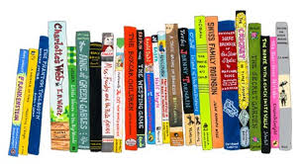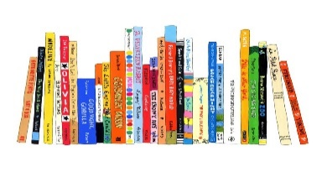

We hope that you find these questions useful and that they are able to help you them with their reading at home. Please feel free to leave comments in your child’s reading record in relation to these questions.

**Supporting your child with reading at home**



We hope that you find these questions useful and that they are able to help you them with their reading at home. Please feel free to leave comments in your child’s reading record in relation to these questions.

**While reading the book:**

* **What type / genre of book is this? How do you know?**
* **Who is telling the story?**
* **What words has the author used to help create effect?**
* **What do you think will happen next? Can you explain why you think that?**
* **How do you think this might end?**
* **Who is your favourite character so far and why?**
* **Can you find two sentences that describe the setting?**
* **What words are used to describe the characters in the story?**
* **Why has the author used a new paragraph here? Has the idea changed? Is there a change in time or setting?**