**Geography Vocabulary**

**Why does time shift?**

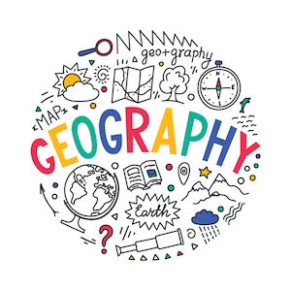

Time zone _____________________________

prime meridian __________________________

latitude _______________________________

longitude ______________________________

