**Art Vocabulary**

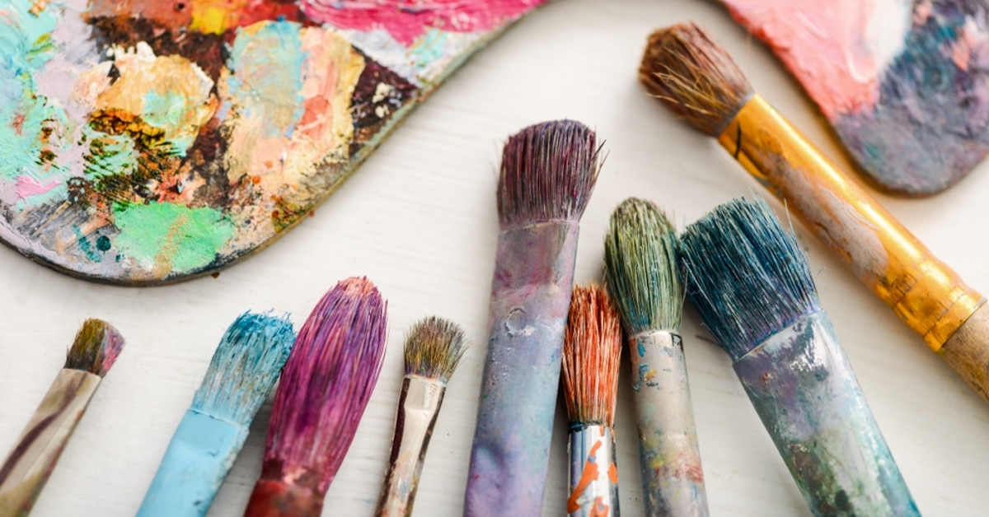

grades of pencil light dark

tone texture scale

**Art Vocabulary**



predict accurate mix thick thin shape texture   
pattern line

**Art Vocabulary**



manipulate texture accuracy collage sculpture annotation elaborate detail Seurat